**تصميم نظام تحكم لخط الإنتاج**

- الحساسات المستخدمة:

2 Ultrasonic Sensor

- المتحكم المستخدم:

Arduino

- المحركات المناسبة:

1 Servo Motor

- الدائرة الإلكترونية:

Production line needs to separate boxes within 3 different sizes, 10cmx10cm, 20cmx20cm, and 30cmx30cm. Having 2 ultrasonic sensors within different heights, Ultrasonic sensor #1 in 25cm, and ultrasonic sensor #2 in 15cm. (Taking into consideration that with the box slides it won’t affect the sensor placed).

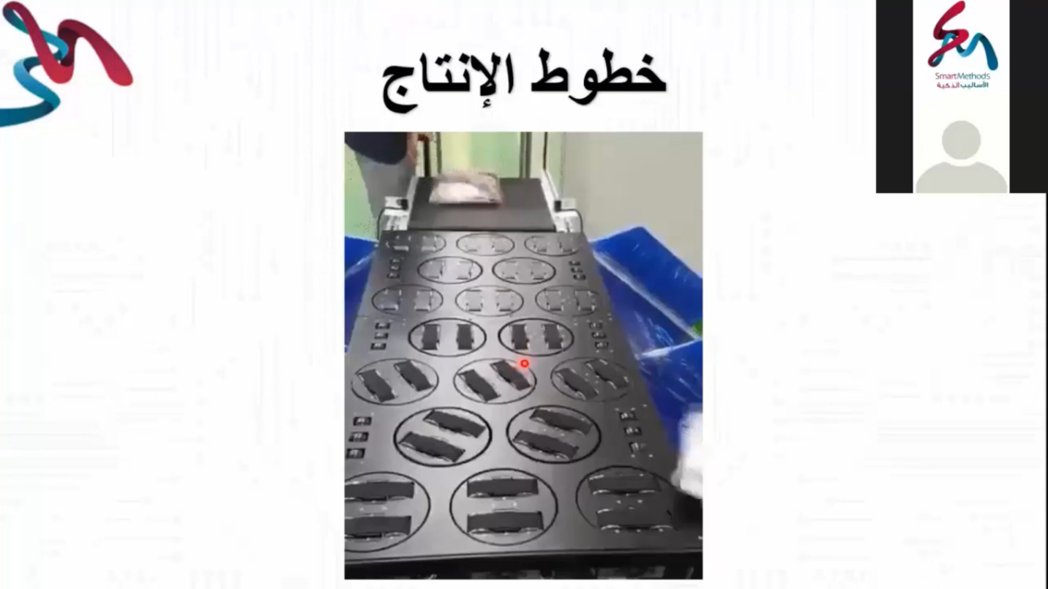

20 cm

Ultrasonic Sensor #2

1 m

Figure 1: Production Line

Ultrasonic Sensor #1

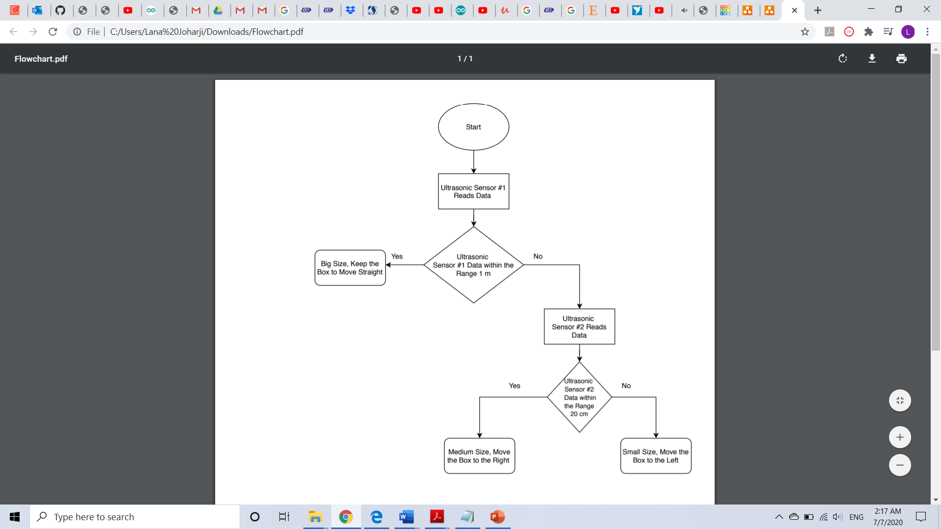

Figure 2: Flowchart

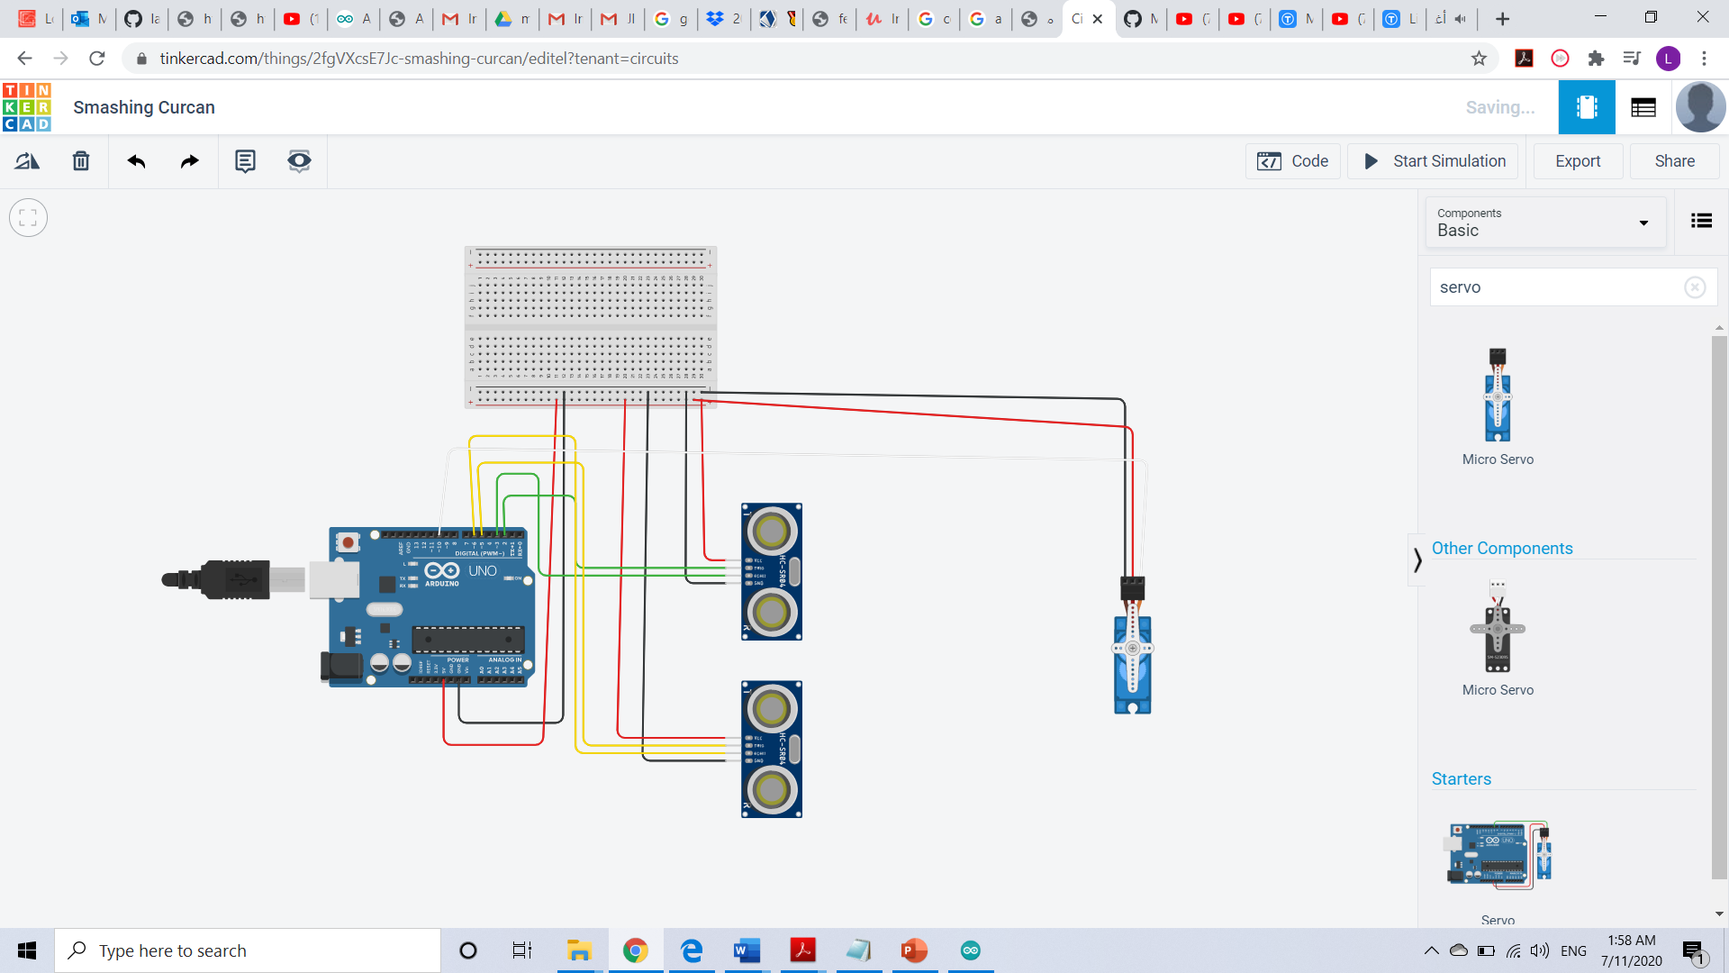

Figure 3: Circuit

- برمجة المتحكم الإلكتروني:

#include <Servo.h>

Servo motor; // servo object

int trig1 = 2; // pin of ultrasonic1

int echo1 = 3; // pin of ultrasonic1

int trig2 = 5; // pin of ultrasonic2

int echo2 = 6; // pin of ultrasonic2

int x1 = 0; // duration of pulses of ultrasonic1

int d1 = 0; // distance of ultrasonic1

int x2 = 0; // duration of pulses of ultrasonic2

int d2 = 0; // distance of ultrasonic2

void setup() {

motor.attach(10); // servo motor pin

pinMode(trig1,OUTPUT);

pinMode(echo1,INPUT);

pinMode(trig2,OUTPUT);

pinMode(echo2,INPUT);

Serial.begin(9600);

}

void loop() {

digitalWrite(trig1,LOW);

delayMicroseconds(2);

digitalWrite(trig1,HIGH);

delayMicroseconds(10);

digitalWrite(trig1,LOW);

digitalWrite(trig2,LOW);

delayMicroseconds(2);

digitalWrite(trig2,HIGH);

delayMicroseconds(10);

digitalWrite(trig2,LOW);

x1 = pulseIn(echo1,HIGH);

d1 = x1 * 0.034 / 2; // distance in cm

Serial.print("Distance of ultrasonic1 is: ");

Serial.println(d1);

x2 = pulseIn(echo2,HIGH);

d2 = x2 * 0.034 / 2; // distance in cm

Serial.print("Distance of ultrasonic2 is: ");

Serial.println(d2);

if (d1>0 && d1<=100){ // Big Size

motor.write(90); // 90 degrees

}

else if (d2>0 && d2<=20){ // Medium Size

motor.write(160); // 160 degrees

}

else { // Small Size

motor.write(45); // 45 degrees

}

}

Other code to use:

#include <Servo.h>

Servo motor; // servo object

int trig1 = 2; // pin of ultrasonic1

int echo1 = 3; // pin of ultrasonic1

int trig2 = 5; // pin of ultrasonic2

int echo2 = 6; // pin of ultrasonic2

int x1 = 0; // duration of pulses of ultrasonic1

int d1 = 0; // distance of ultrasonic1

int x2 = 0; // duration of pulses of ultrasonic2

int d2 = 0; // distance of ultrasonic2

void setup() {

motor.attach(10); // servo motor pin

pinMode(trig1,OUTPUT);

pinMode(echo1,INPUT);

pinMode(trig2,OUTPUT);

pinMode(echo2,INPUT);

Serial.begin(9600);

}

void loop() {

digitalWrite(trig1,LOW);

delayMicroseconds(2);

digitalWrite(trig1,HIGH);

delayMicroseconds(10);

digitalWrite(trig1,LOW);

digitalWrite(trig2,LOW);

delayMicroseconds(2);

digitalWrite(trig2,HIGH);

delayMicroseconds(10);

digitalWrite(trig2,LOW);

x1 = pulseIn(echo1,HIGH);

d1 = x1 * 0.034 / 2; // distance in cm

Serial.print("Distance of ultrasonic1 is: ");

Serial.println(d1);

x2 = pulseIn(echo2,HIGH);

d2 = x2 * 0.034 / 2; // distance in cm

Serial.print("Distance of ultrasonic2 is: ");

Serial.println(d2);

while (d1>0 && d1<=100){ // Big Size

motor.write(90); // 90 degrees

}

while (d2>0 && d2<=20 && d1>100){ // Medium Size

motor.write(160); // 160 degrees

}

while(d1>100 && d2>20) { // Small Size

motor.write(45); // 45 degrees

}

}

- تشغيل وتجربة النظام: